

COVER SHEET

Student Name: | Abdulla | Module Name: | Object Oriented Programming with C++
Student ID: | TM223-0927 | Module Code: | COS212
Assessment Type: | Individual Assessment | Learning Outcomes Assessed:
Deadline: | 7 May 2026 | Date of Submission: | 3 May 2026
Institution: | TMC Institute in Tashkent

Signature of Assessor: | Signature of Moderator: |  | Overall, Mark (subject to ratification by exam board)
This work is fully done by me and I referenced all the sources I used in this work.
Student signature: |  | Abdurahmanov Abdulla Ravshanovich

Library Management System

Introduction
This is a console-based Library management system developed in C++. It allows managing a collection of books with the help of CRUD operations and file storage.

Main Functionality

1. Add Book
The user can add a book by entering:
- Book ID ( unique)
- Title
- Category (A/B/C)
- Price

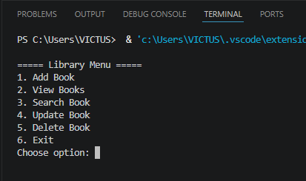

2. View Books
All books that are in the system are displayed, including
- ID
- Title
- Category
- Price
- Status (Available / Borrowed)
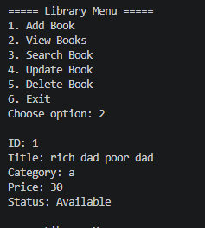

3. Search Book
Allows the user to enter the id of the book, if the ID exists, the book is displayed with details.

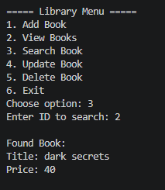

4. Update Book
The user can update the book price and status (Available or Borrowed)
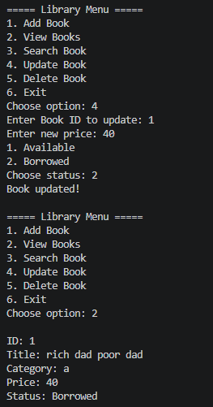

5. Delete Book
Deletes a book by its ID. If the system finds the book, it will be deleted.

6. Data Persistence (File Handling)
When a user adds a new book, it is automatically saved in a file (library.txt). Then the data is automatically loaded when the program starts. This ensures that no data is lost between sessions.

Input Validation
The system performs some validation checks to ensure that input data is correct.
The Id must be a number and unique. The price must be a valid number and cannot be negative value. cin.fail() is used to detect invalid input (e.g., letters instead of numbers.

// Validate input and check for duplicate ID
if (cin.fail() || !isUnique(b.id)) {
cin.clear();
cin.ignore(1000, '\n');
cout << "Invalid or duplicate ID!\n";
return;
}

.
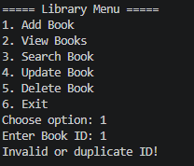

// Validate price input
if (cin.fail() || b.price < 0) {
cin.clear();
cin.ignore(1000, '\n');
cout << "Invalid price!\n";
return;
}

Validate category input

// VALIDATED CATEGORY INPUT
while (true) {
cout << "Enter Category (A/B/C): ";
cin >> b.category;

b.category = toupper(b.category);

if (b.category == 'A' || b.category == 'B' || b.category == 'C') {
break;
} else {
cout << "Invalid category! Please enter A, B, or C.\n";
}
}

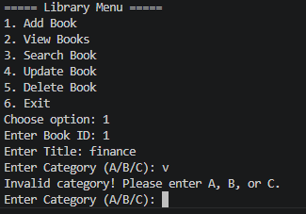

Conclusion
This application is simple but demonstrates a complete system for managing books. It includes user interaction, data validation, file storage and core programming concepts.

